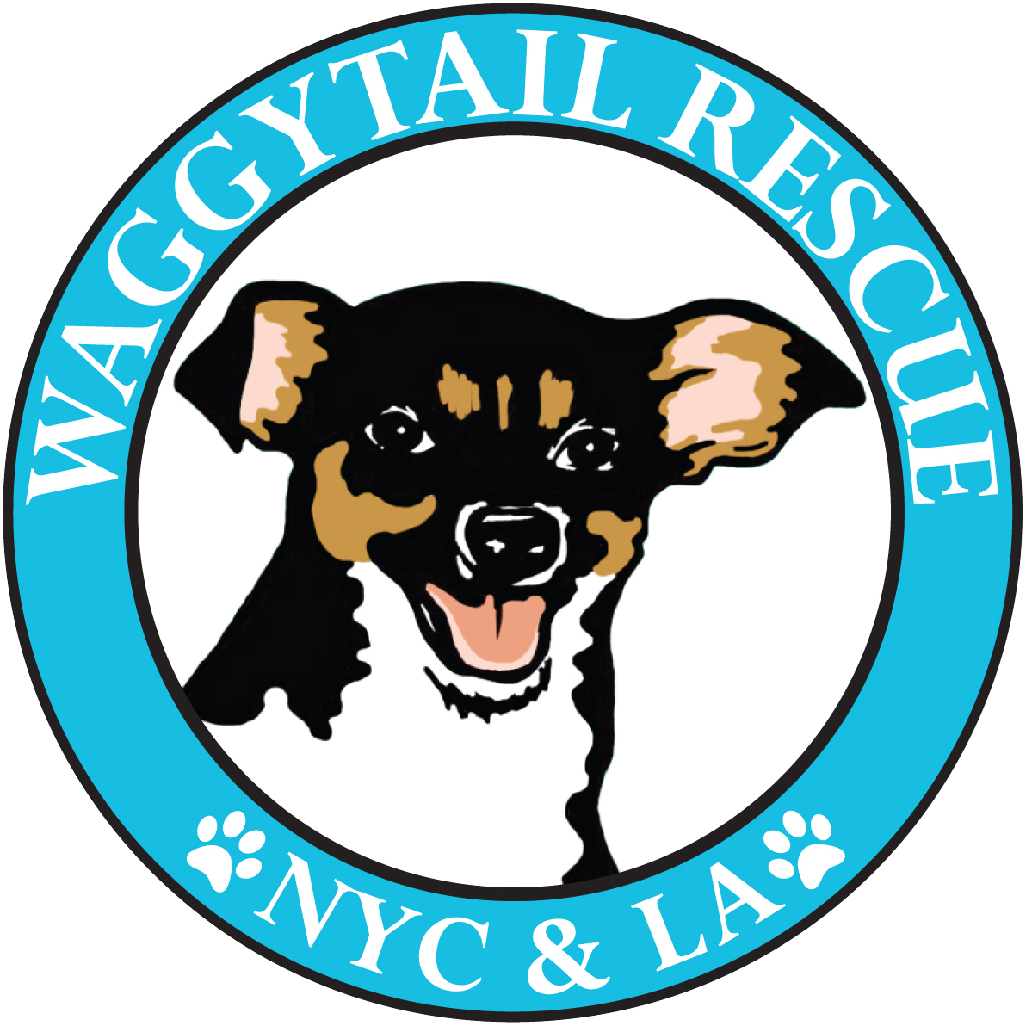
WAGGYTAIL RESCUE
FLIGHT TRANSPORT
APPLICATION

Please return to: waggyvolunteer@gmail.com

NAME:
AGE:
EMAIL:
CELL PHONE:
EMOTIONAL SUPPORT ANIMAL CERTIFIED:

DATE OF FLIGHT:
AIRLINE & FLIGHT #:
DEPARTURE/ARRIVAL AIRPORTS:
SCHEDULED DEPARTURE TIME:
SCHEDULED ARRIVAL TIME:

PLACE OF STAY
Street:
City:
Zip:

DESTINATION IN NEW YORK
Street:
City:
Zip:

AS A THIRD PARTY WAGGYTAIL RESCUE IS UNABLE TO ADD THE DOG’S TICKET TO YOUR FLIGHT. ONCE A DOG HAS BEEN CONFIRMED TO TRAVEL WITH YOU, CALL YOUR AIRLINE TO ADD THE DOG’S CARRY-ON TICKET. OUR PROVIDED CARRIERS ARE ALL SOFT SIDED AND AIRLINE APPROVED SIZES FOR CABIN.

Please INVOICE via PayPal (waggytailrescue@gmail.com) or Venmo (Waggytail Rescue) with a copy of your receipt for reimbursement after your flight. If you require a check please provide a mailing address below:

Are you able to take a dog before your flight? Please specify length of time (hours/days etc.) if any.

Are you able to take a dog at your hotel/place of stay or do you need airport hand off?

Do you agree that if any unforeseen issues arise with your flight that you ensure the dog makes it safely to your final destination in NYC?

IN NEW YORK:
Are you able to transport the dog to your final destination in NYC for a transfer to a foster, or do you need an airport hand off? Non-airport is the easiest for us to organize and we require more time to organize airport pick-up by a volunteer.

How long can you care for a dog in NYC before needing a transfer to a foster (hours, a day, a week etc.)?

If you can foster your pup in NYC for more than a day or two, please click here to fill in a foster application and add to it to the end of this document!

PERSONAL REFERENCES:
Please provide the names and contact details of TWO people who can vouch for your ability to be responsible for an animal while traveling!

Name:
Relationship to you:
Cell:

Name:
Relationship to you:
Cell:

- If you are approved a Waggytail representative will work with you via email or phone to iron out logistics and to put you in contact with our volunteers/fosters.
- You will need to contact the airline you are flying on in advance to book the dog’s place in carry-on as some airlines restrict the number of animals allowed in cabin.
- We will reimburse the cost of the dog’s plane fare as well as providing the dog, an airline approved dog carrier and a leash/harness. Please invoice us!
- The dog’s paperwork (and medication if applicable) will be in the carrier.
- All supplies and paperwork should remain with the dog and be passed on to the foster. They are the property of Waggytail and will be reused for future flights!
- If you fly frequently to NYC and can keep bringing dogs, we love you! Please fill in a new application each time so that we have the correct flight details!

Thanks for applying to be a Waggytail Flight Attendant!
If you have any questions please contact us at waggyvolunteer@gmail.com!

